edit the name

I kept them openstack

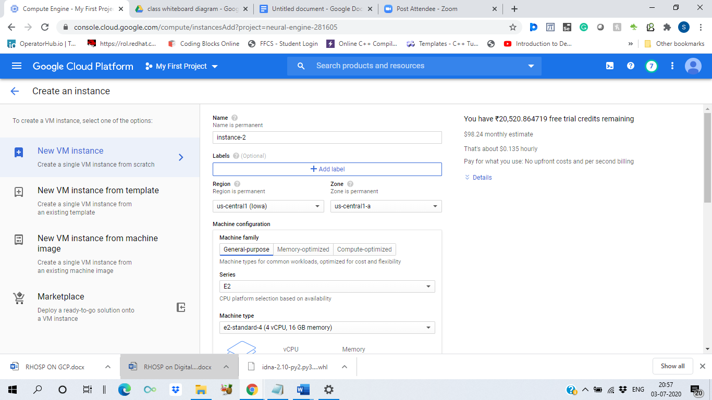

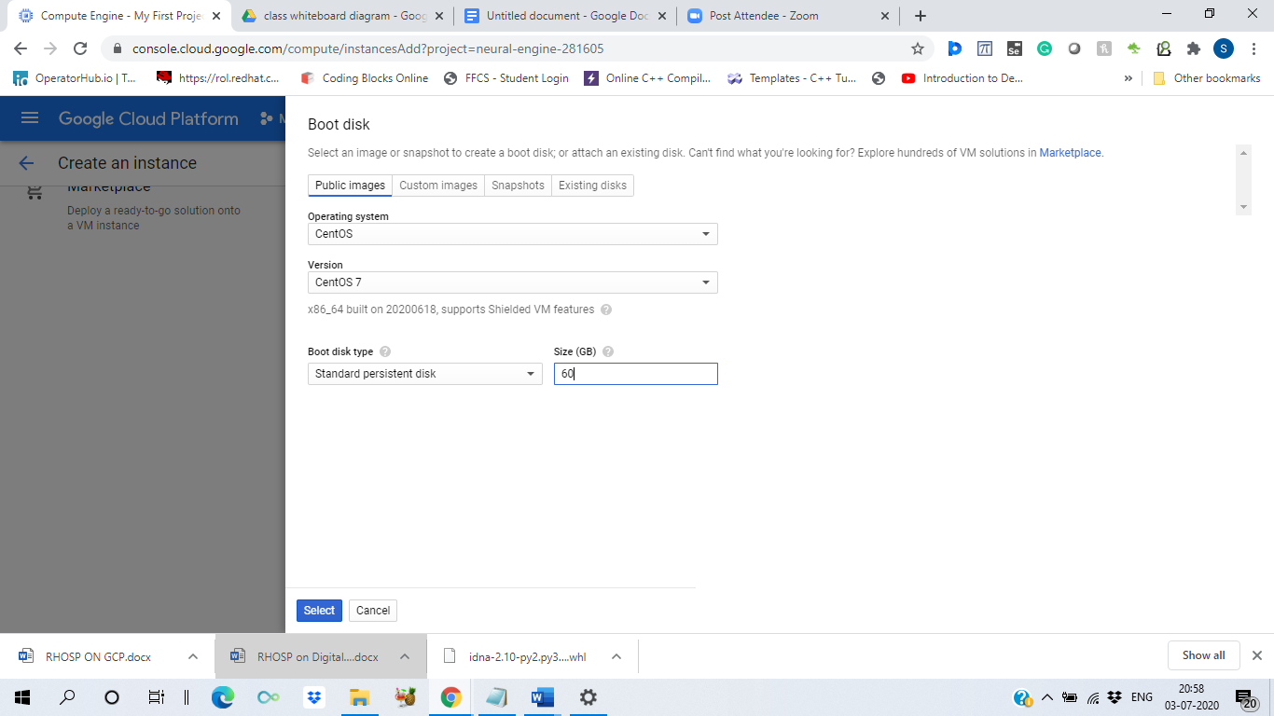

select this both

Allow HTTP traffic

Allow HTTPS traffic

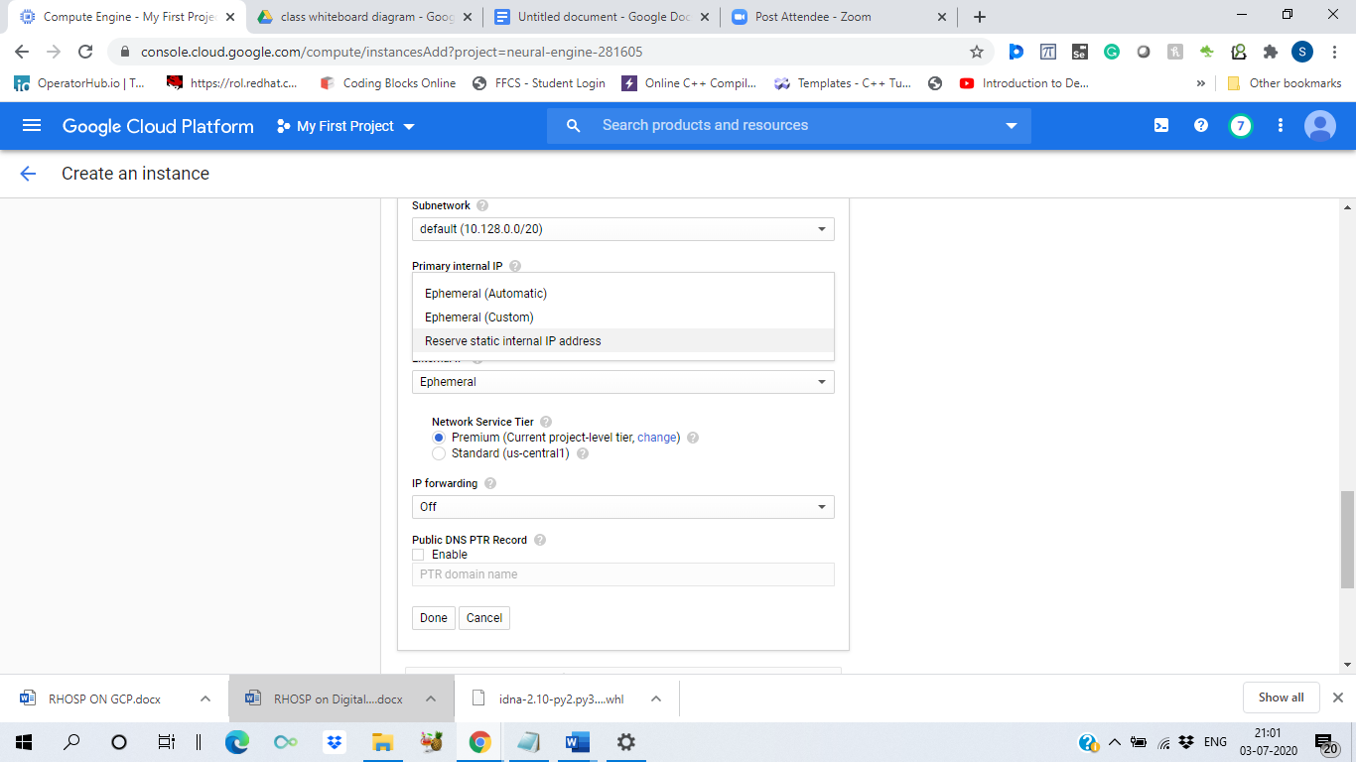

reserve or make your public as well as private ip static

And press Done

And press create

ssh into the instance

sudo su – root

1 nmcli con show

2 ifconfig

3 route -n

4 cat /etc/resolv.conf

5 yum list | grep createrepo

6 ls

7 ifconfig

8 nmcli con show

9 nmcli con add con-name rhosp ifname eth0 type ethernet ip4 10.128.0.8/32 gw4 10.128.0.1 ipv4.dns 169.254.169.254 connection.autoconnect yes

10 nmcli con show

11 nmcli con down "System eth0"

12 nmcli con up rhosp

13 nmcli connection show

14 ping goo.gl

15 nmcli connection show rhosp

16 yum update -y

17 yum install python3 -y

18 pip3 install gdown

19 gdown --id 1dcKO8Hkuj20RZQGjs4zFPTpVz3jw6fBI

20 gdown --id 1DX_LkU7CMsjS_FGTUUKyVZubUP5V2Ai3

21 gdown --id 18Obvas7ZUleTUiS8yDeeTMRVPzfzBbTs

22 mkdir /iso1

23 mount "Copy of rhel-7.5-server-updates-20180628.iso" /iso1

24 mkdir /iso2

25 mount "Copy of rhel-7-server-additional-20180628.iso" /iso2

26 mkdir /iso3

27 mount "Copy of RHEL7OSP-13.0-20180628.2-x86_64.iso" /iso3

28 mkdir /software

29 cp -rvf /iso1/ /software/

30 cp -rvf /iso2/ /software/

31 cp -rvf /iso3/ /software/

32 yum install createrepo -y

33 cd /software/

34 createrepo -v .

35 ls

36 vim /etc/yum.repos.d/rhosp.repo

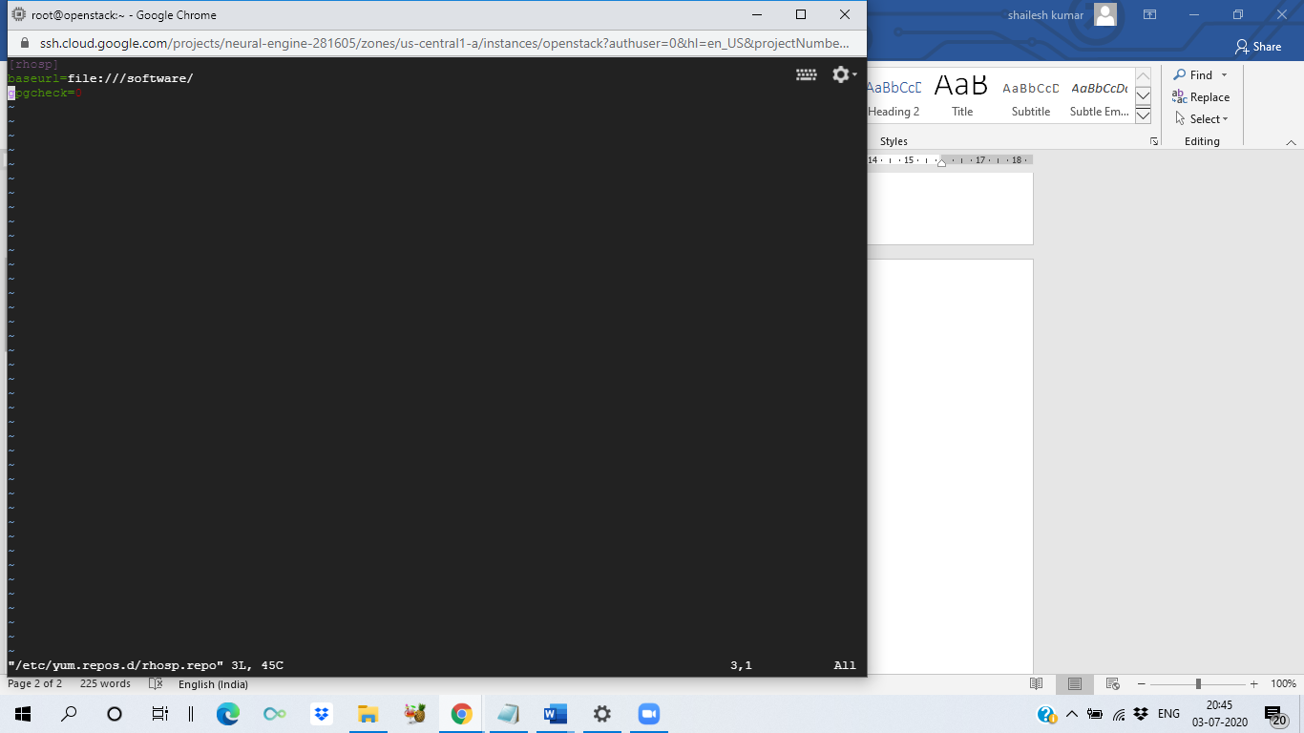

37 yum clean all

38 yum repolist

40 vim /etc/ssh/sshd_config

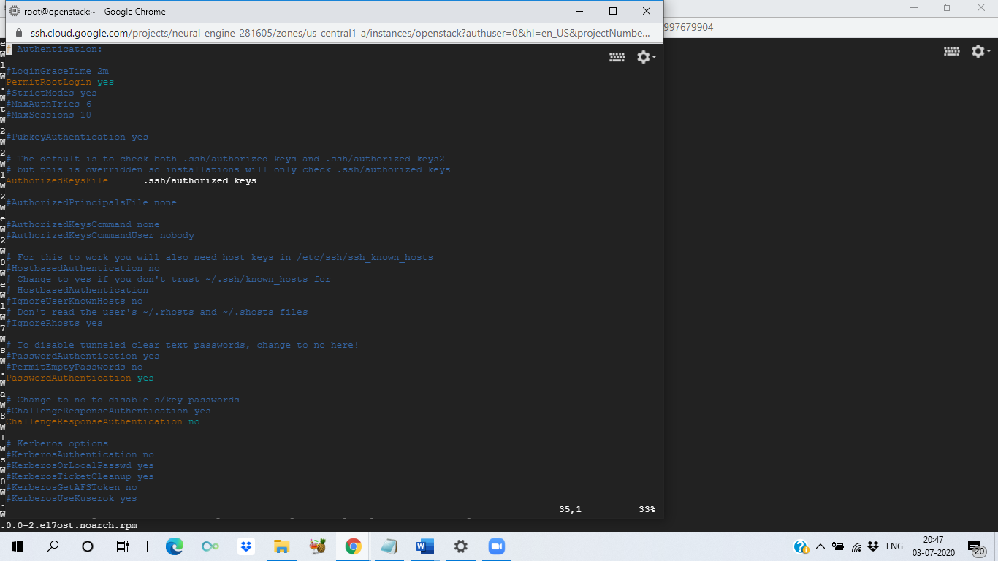

line38 PermitRootLogin yes

line65 linePasswordAuthentication yes

41 passwd root

42 systemctl restart sshd

43 systemctl stop NetworkManager

44 systemctl disable NetworkManager

45 systemctl stop firewalld

46 yum install openstack-packstack -y

47 setenforce 0

48 ssh-copy-id root@localhost

49 ssh-keygen

50 ssh-copy-id root@localhost

51 packstack --gen-answer-file=a.txt

52 vim a.txt

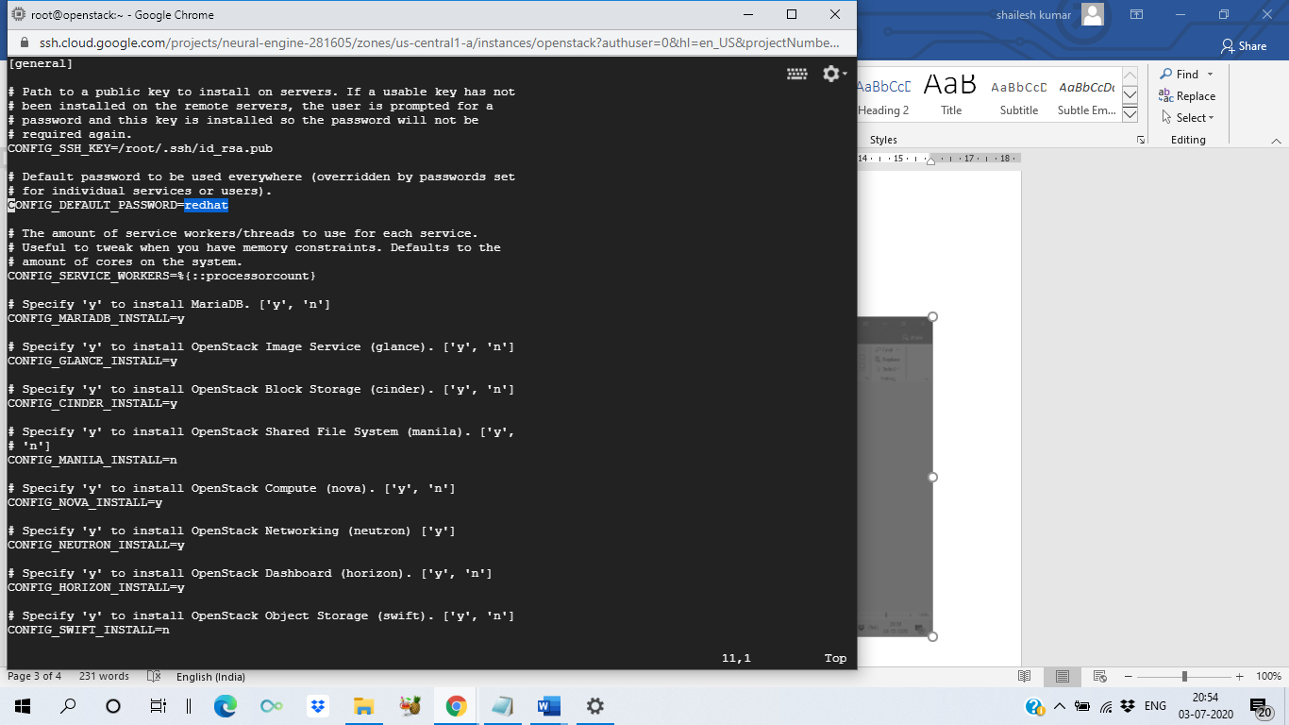

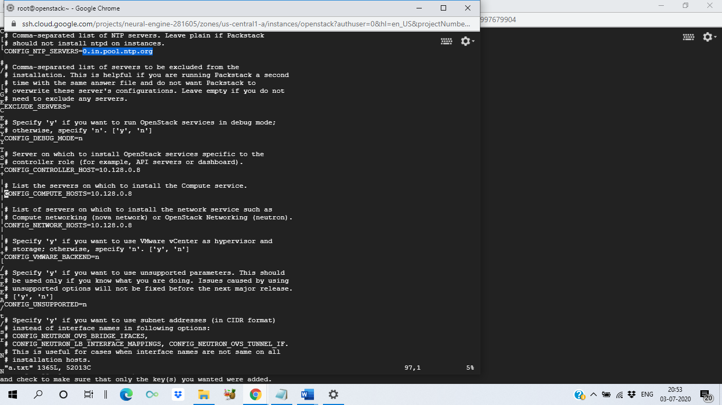

53 free -m

54 packstack --answer-file=a.txt

55 ls

56 cat keystonerc_admin

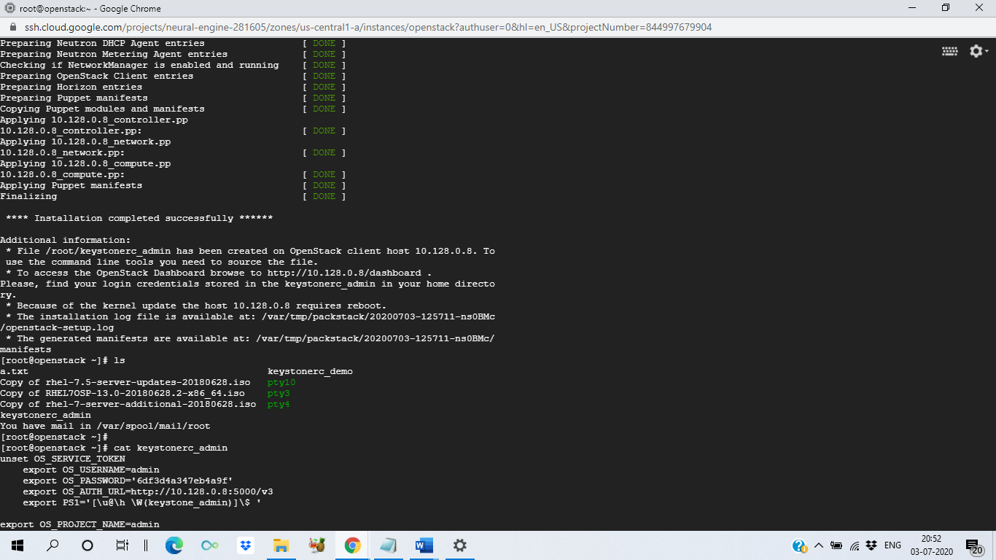

cd /etc/httpd/conf.d/

vim 15-horizon_vhost.conf

inside the file

ServerAlias <your-public-ip>

